11/12/2019

ACME Entertainment Pty Ltd

South Metropolitan TAFE

Software Development Master Document

Rapid Application Development

Table of Contents

Meeting Minutes 5

External Meeting with Client 5

Internal Meeting 6

Multi-Platform Report 7

Definition of Adaptive and Responsive Web Design 7

Responsive Web Design 7

Adaptive Web Design 8

Comparisons of Responsive Web Design and Adaptive Web Design 8

Responsive is Harder to Make 8

Adaptive is Less Flexible 8

Responsive Sites Load Faster 9

Is Responsive design better than Adaptive? 9

Conclusion: 9

Should you use Responsive or Adaptive design for your sites? 9

Bibliography 10

Glossary of Term 11

**Cascading Style Sheets (CSS)** - This is a stylesheet language used to describe the presentation of a document written in HTML or XML. 11

Source Control 12

Project Management Plan version 1 13

Software Development Testing Plan 14

Overview 14

Functional and Regression Testing 14

GUI and Usability Testing 14

Accessibility Testing 14

Compatibility Testing 14

Performance Testing 14

Installation / Configuration Testing 14

System Integration Testing (SIT) 14

Security Testing 14

Internationalization / Localization Testing 15

User Acceptance Testing (UAT) 15

Testing Table 15

Screenshot 16

Bibliography 22

Glossary of Term 23

Analysis documentation 24

CITE Business Rules for Software Development 24

The Common Aspects of CITE Coding Standard: 24

The following “ 24

CITE Managed Service Quality Assurance 24

Quality Management Services’ Tasks and Objectives 24

Comprehensive Approach to Quality 24

Independent QA Department 25

Quality Assurance Life Cycle 25

ACME Entertainment Pty Ltd development requirements 26

Functional Requirements: 26

Non –Functional Requirements: 26

Bibliography 27

Glossary of Term 28

Meeting Minutes 29

Meeting Minutes(Allocation) 29

Meeting Minutes(Requirements) 30

Software Review Plan 32

Introduction 32

IEEE Standard 1028 32

Management Preparation 32

Objectives for this Web Application 32

Overview of the Objectives 33

Individual Preparation 33

Group Examination 33

Defect Prevention 34

Conclusion: 34

Bibliography 35

Glossary of Term 36

Performance Report 37

Introduction 37

Client’s Project Outline 38

Languages for developing website and database 38

Website functionality 38

Home 38

Search 38

Show All Movies 38

Top 10 Movies 38

Memberships 38

Admin 38

Code Optimization 39

What is Code Optimization? 39

Advantages of code optimization 39

When should not do code optimization? 39

Example to code optimization tools 39

Performance Testing 40

What is performance testing? 40

Types of Performance Testing 40

Performance Testing Process 40

Performance Testing Metrics 40

Performance Test Tools 41

Bibliography 42

Glossary of Term 43

Project Management Plan Sprint Two 44

Software Development Testing Plan for Sprint Two 45

Overview 45

Functional and Regression Testing 45

GUI and Usability Testing 45

Accessibility Testing 45

Compatibility Testing 45

Performance Testing 45

Installation / Configuration Testing 45

System Integration Testing (SIT) 45

Security Testing 45

Internationalization / Localization Testing 46

User Acceptance Testing (UAT) 46

Testing Table 46

Screenshot 47

Bibliography 67

Glossary of Term 68

Sprint One

# Meeting Minutes

## External Meeting with Client

ACME Entertainment Pty Ltd

|  |  |
| --- | --- |
| Present: | Jayden Lee, Daniel Hee, Tze Hon, Stewart Godwin (Client) |
| Date | Time: | 5 November 2019, 09:00 AM |

1. Purpose of this meeting

This is a meeting between the team members and the client. The purpose of this meeting it to identify the client needs and requirement.

1. Requirement#1 – Have a Source Control

* Identify which source control program to use
* Upload all documentation or report for Sprint One
* Have version control – this will records changes to a file

1. Requirement#2 – Have a Project Management Plan

* List out all the Task for Sprint One
* Have version control – this will allow the client to keep track on the progress
* Provide a time frame for each task
* List out which team member is responsible on which task

1. Requirement#3 – Have a Software Development Testing Plan

* List out all possible testing agenda
* Ensure all testing agenda met the requirement
* Ensure this plan will includes the Quality Assurance standards of CITE

1. Requirement#4 – Documentation should be formatted properly

* Ensure all documentation have the same fonts, heading, font size.
* Ensure all documentation have table of contents, reference, and glossary of term (if needed).

1. Requirement#5 – Have a Multi-Platform Report (Adaptive v Responsive)

* Explain Adaptive and Responsive Design
* Comparison between both design
* Recommendation whether to choose Adaptive or Responsive design for the site

## Internal Meeting

ACME Entertainment Pty Ltd

|  |  |
| --- | --- |
| Present: | Jayden Lee, Daniel Hee, Tze Hon |
| Date | Time: | 5 November 2019, 11:30 AM |

1. Purpose of this meeting

This is an internal meeting between the team members. The purpose of this meeting is to identify the project parameters and allocate work to each team member.

1. Team Member#1 – Daniel Hee

This team member will have the following roles:

* Present Sprint One to the Client
* Provide a Report regarding the Multi-Platform which are Responsive and Adaptive Web Design
* Cascading Sheet Styles (CSS) Formatting for the site after deciding which types of web design to implement
* Provide Comment on Code and Code Modularity

1. Team Member#2 – Jayden Lee

This team member will have the following roles:

* Provide a project management plan for our project
* Cascading Sheet Styles (CSS) Formatting for the site after deciding which types of web design to implement
* Provide a Software Development Testing Plan which includes the Quality Assurance standards of CITE
* Provide full term of acronyms found in any report

1. Team Member#3 – Tze Yee Hon

This team member will have the following roles:

* Provide an analysis report
* Cascading Sheet Styles (CSS) Formatting for the site after deciding which types of web design to implement
* Format Template or Report’s fonts, sizes, heading, Table of Contents, etc

# Multi-Platform Report

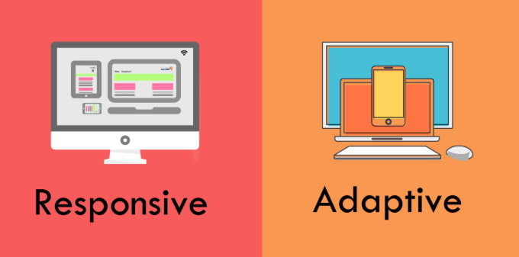

FIGURE 1.1

## Definition of Adaptive and Responsive Web Design

## Responsive Web Design

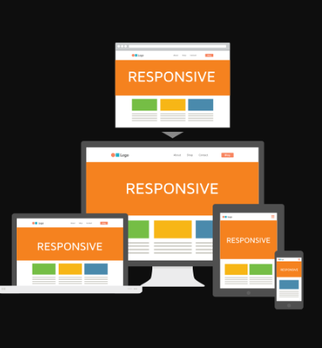Responsive Web Design provides an optimal viewing experience of a website, regardless of what types of device the user is using.

FIGURE 1.2 – Example of Responsive Design

## Adaptive Web Design

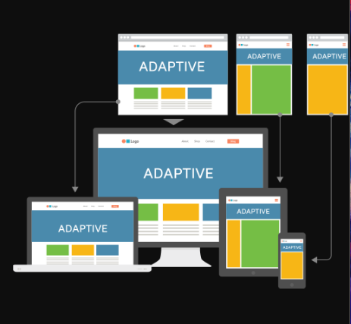Adaptive Web Design provides a multiple layout for multiple screen sizes and the layout used depends on the screen size used.

FIGURE 1.3 – Example of Adaptive Design

## Comparisons of Responsive Web Design and Adaptive Web Design

## Responsive is Harder to Make

Responsive Design are harder to implement due to the extra efforts needed for the site’s “CSS” in order to ensure that it functions well at any possible size. So, for Adaptive Design, you only need to make a few specific layouts which work on several screen sizes which makes it easier than making one layout that works for all of them.

## Adaptive is Less Flexible

The one disadvantages of using Adaptive Design is that the result do not always display the best for a wide variety of screen sizes. While for responsive site design, it will be able to works well on any kinds of screen sizes. Responsive sites can keep working on its own, adaptive sites may need some maintenance from time to time.

## Responsive Sites Load Faster

Responsive sites load faster because it only loads the one that works across all platforms but for adaptive sites it need to load all possible layouts. For adaptive sites, it has more layouts which it will take more time and resources to load.

## Is Responsive design better than Adaptive?

If you have in mind what specific devices your site must support, adaptive design might be easier and more efficient than Responsive. However, responsive design is good way for future-proofing a site against any possibility that a new device launched on the market.

## Conclusion:

## Should you use Responsive or Adaptive design for your sites?

Personally, I would choose Responsive Design as it is the safer option to go with your sites. It is because it required less maintaining as it will respond to any new screen sizes as they released which provides a longer lease of life for your sites, but Responsive design takes a lot of effort to implement. Responsive Design also improve the times taken to load your sites.

## Bibliography

*Responsive vs Adaptive Design – Which is Best for Mobile Viewing of Your Website?* (n.d.). Retrieved from Medium Well: http://mediumwell.com/responsive-adaptive-mobile/

Strachan, J. (2019, December 12). *Adaptive vs responsive web design*. Retrieved from UX Planet: https://uxplanet.org/adaptive-vs-responsive-web-design-eead0c2c28a8

## Glossary of Term

## **Cascading Style Sheets (CSS)** - This is a stylesheet language used to describe the presentation of a document written in HTML or XML.

# Source Control

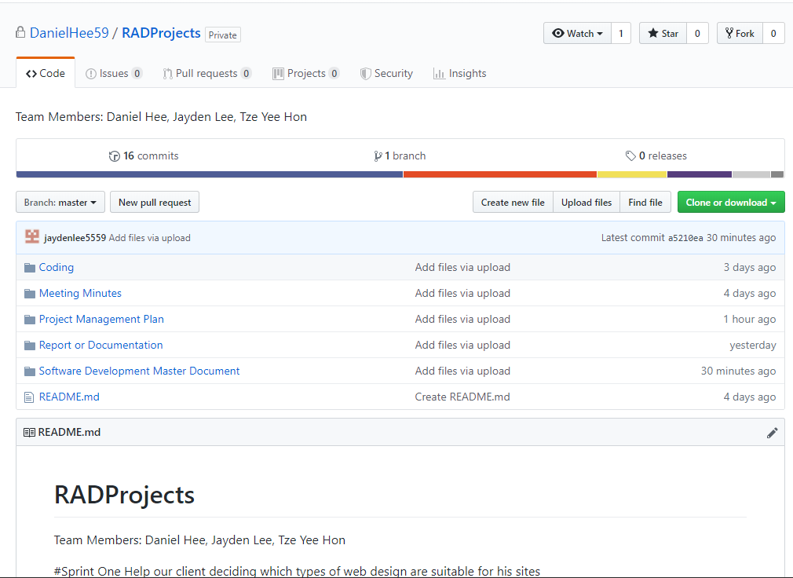

# Project Management Plan version 1

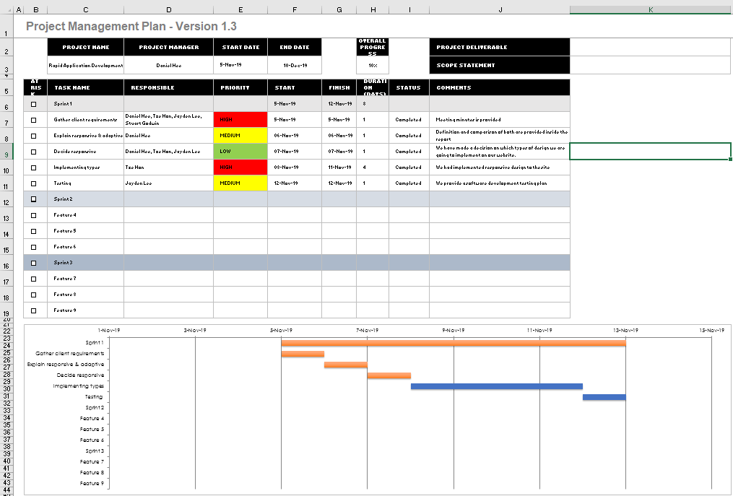

# Software Development Testing Plan

## Overview

This Software Development Testing Plan (SDTP) is used to test out the features and functionality of the Responsive Design website according to the CITE Quality Assurance as below:

## Functional and Regression Testing

**Functional testing** is performed to ensure all functionalities of an application is working as expected.

**Regression testing** is performed once a build is released to check the existing functionality. (360 Logica, n.d.)

## GUI and Usability Testing

**Usability Testing** is focused on the end user and checks the impressions of the application usage.

**GUI Testing** is performed on various platforms in order to check the look and feel of the application.

(Professional QA, n.d.)

## Accessibility Testing

Performed to ensure that the application being tested is usable by people with disabilities like hearing, color blindness, old age and other disadvantaged groups.

(Guru 99, n.d.)

## Compatibility Testing

Check whether the software is capable of running on different hardware, operating systems, applications, network environments or Mobile devices.

(Guru 99, n.d.)

## Performance Testing

**Performance testing** is the process of determining the speed, responsiveness and stability of a computer, network, software program or device under a workload.

(Guru 99, n.d.)

## Installation / Configuration Testing

Test the performance of a software product on a machine with different hardware or software configurations namely, operating system, browser, supported drivers.

(Guru 99, n.d.)

## System Integration Testing (SIT)

Carried out in an integrated hardware and software environment to verify the behavior of the complete system. It is testing conducted on a complete, integrated system to evaluate the system's compliance with its specified requirement.

(Wikipedia, n.d.)

## Security Testing

Ensures software systems and applications are free from any vulnerabilities, threats, risks that may cause a big loss.

(Guru 99, n.d.)

## Internationalization / Localization Testing

**Internationalization** is making the application such that it supports multiple languages/locales.

**Localization** is making an application support a particular locale and language.

(Software Testing Help, n.d.)

## User Acceptance Testing (UAT)

Last phase of software testing, users test the software to make sure it can handle required tasks in real-world scenarios, according to specifications.

(Techopedia, n.d.)

## Testing Table

|  |  |  |  |  |
| --- | --- | --- | --- | --- |
| Case No | Test types | Description | Status | Evidence |
| 1 | Functional and Regression Testing | All the functions are works perfectly | Tested | Figure 1 – 4 |
| 2 | GUI and Usability Testing | The website has navigation bar, text boxes and buttons to go thru | Tested | Figure 2.1 |
| 3 | Accessibility Testing | Doesn’t have any functions for disadvantages group such as deaf/blind, disabilities people. | N/A | N/A |
| 4 | Compatibility Testing | Is compatible for different platforms such as laptop, mobiles, and computers, tablets. | Tested | Figure 3 |
| 5 | Performance Testing | No workload is applicable in this testing | N/A | N/A |
| 6 | Installation / Configuration Testing | Work well on different operating system, browsers | Tested | Figure 1 |
| 7 | System Integration Testing (SIT) | Data exchanges (data import/export) happens between the system components (MySQL & HTML/PHP) and then the behavior of each data field within the individual layer is examined. | Tested | Figure 4 |
| 8 | Security Testing | Security features likes authorization credentials isn’t implemented in this project | N/A | N/A |
| 9 | Internationalization / Localization Testing | Its only available in English languages | N/A | N/A |
| 10 | User Acceptance Testing (UAT) | End users testing with the basic functions of searching movies, show all movies, and top 10 movies | Tested | Figure 1 – 4 |

## Screenshot

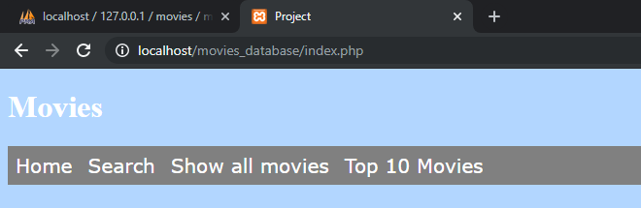

Figure 1.1 Google Chrome browser

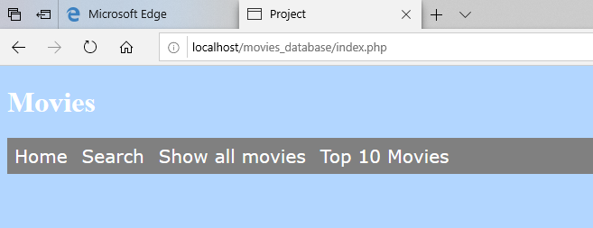

Figure 1.2 Microsoft Edge browser

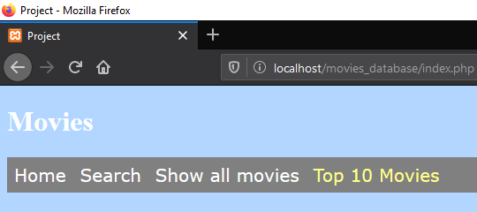

Figure 1.3 Mozilla Firefox browser

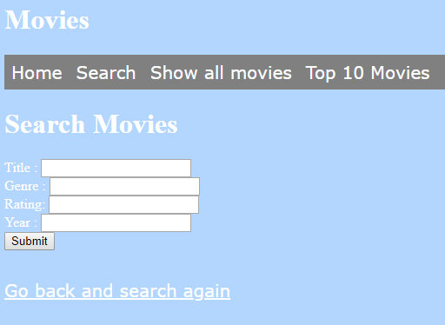

Figure 2.1 – GUI – Navigation bar, text boxes, buttons, and hyperlinks

  
Figure 3.1 – iOS Mobile landscape mode

  
Figure 3.2 – iOS Mobile portrait mode

  
Figure 3.3 – iOS tablet landscape mode

  
Figure 3.4 – iOS tablet portrait mode

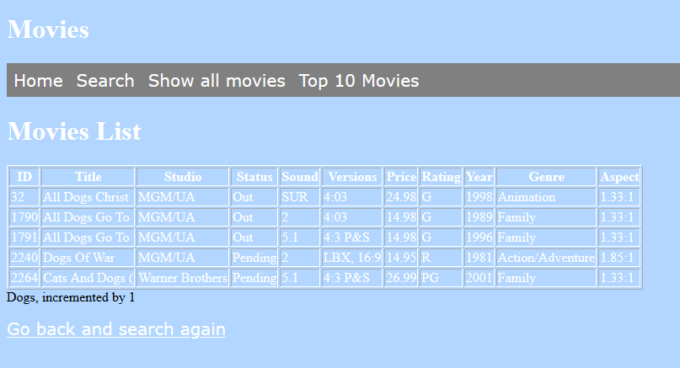

Figure 4.1 – Search function works well with database

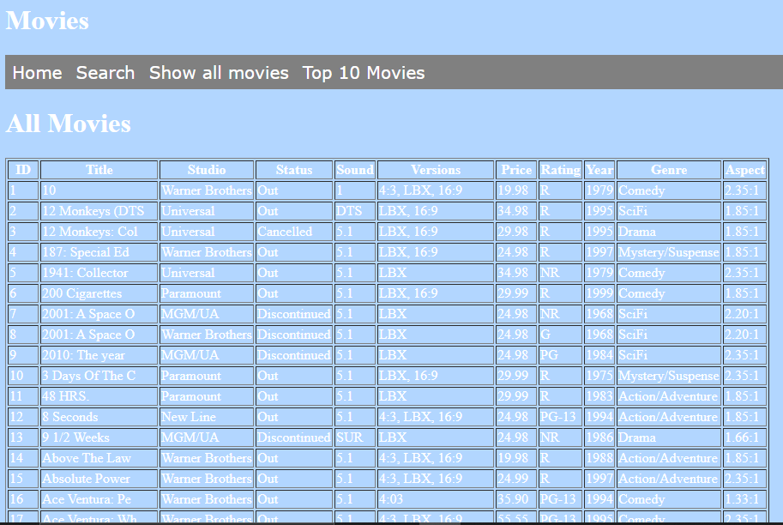

Figure 4.2 – All movies pages

## Bibliography

*360 Logica*. (n.d.). Retrieved from https://www.360logica.com/blog/regression-testing-vs-functional-testing/

*CITE Managed Services*. (n.d.). Retrieved from http://www.citems.com.au/?page_id=84

*Guru 99*. (n.d.). Retrieved from https://www.guru99.com/accessibility-testing.html

*Guru 99*. (n.d.). Retrieved from https://www.guru99.com/compatibility-testing.html

*Guru 99*. (n.d.). Retrieved from Performance Testing: https://www.guru99.com/performance-testing.html

*Guru 99*. (n.d.). Retrieved from Configuration Testing: https://www.guru99.com/configuration-testing.html

*Guru 99*. (n.d.). Retrieved from Security Testing: https://www.guru99.com/what-is-security-testing.html

*Professional QA*. (n.d.). Retrieved from http://www.professionalqa.com/gui-testing-vs-usability-testing

*Software Testing Help*. (n.d.). Retrieved from Localization and Internationalization: https://www.softwaretestinghelp.com/localization-and-internationalization-testing/

*Techopedia*. (n.d.). Retrieved from UAT: https://www.techopedia.com/definition/3887/user-acceptance-testing-uat

*Wikipedia*. (n.d.). Retrieved from System Integration Testing: https://en.wikipedia.org/wiki/System_integration_testing

## Glossary of Term

**System Integration Testing (SIT)** – This is a software solution designed to deliver instructional content.

**User Acceptance Testing (UAT)** – This is last phase of the software testing process. During this phase, actual software users test the software to make sure it can handle required tasks in real-world scenarios, according to specifications.

**Graphic User Interface (GUI)** – This is a form of user interface that allows users to interact with electronic devices through graphical icons and audio indicator.

**Structured Query Language (MySQL)** - This is an open-source relational database management system. Its name is a combination of “My”, the name of co-founder Michael Widenius’s daughter, and “SQL”, the abbreviation for Structured Query Language.

**Hypertext Mark-up Language (HTML)** – This is the standard mark-up language for documents designed to be displayed in a web browser.

**Hypertext Pre-processor (PHP)** – This is a general-purpose programming language originally designed for web development.

# Analysis documentation

## CITE Business Rules for Software Development

CITE has their own coding standards to tell developers write all code according to the coding standards outlined by CITE. These standards are to ensure that large project can be coded in a consistent style.

## The Common Aspects of CITE Coding Standard:

* Naming Conventions
* File Naming and Organization
* Formatting and Indentation
* Comments and Documentation
* Pointer and Reference Usage
* Testing

The context of the language and client’s requirements will affect the coding standards. Without meeting the standards, the CITE developers will default to the industry standard.

The following “[ISO](#_Glossary_of_Term" \o "International Organization for Standardization )” Standards will cover all the systems and projects:

* “ISO” / ”IEC” / ”IEEE” 12207:2017 Systems and software engineering – Software life cycle processes.

## CITE Managed Service Quality Assurance

CITE Managed Services has actualized a Quality Management System (QMS) containing a mind-boggling set of engineering and managerial activities that guarantee bespoke quality of delivered software throughout the whole work process

## Quality Management Services’ Tasks and Objectives

* Elaboration and execution of methods and guidelines for software development process dependent on industry standards and best practices
* Product lifecycle monitoring to make sure compliance with established processes and guidelines
* Product quality verification and validation to ensure that it conforms with client’ business necessities and expectancy
* Establishment of an efficient teamwork between all project team members

## Comprehensive Approach to Quality

* Quality Planning
  + During the development cycle of each project, CITE Managed Services will gather the suitable sets of standards, regulations, procedures, guidelines and tools in quality plans
* Quality Assurance
  + To ensure that quality standards are being followed and delivered software implemented with client’s requirement, CITE Managed Services has established processes that appraise project performance
* Quality Control
  + CITE Managed Services will measure performance trends to evaluate defective pieces of code and ensure that deliverables are high quality and correct

## Independent QA Department

CITE Managed Services has an independent “QA” department. The “QA” department leads by experienced “QA” engineers who engaged in projects on a committed or an on-demand basis. The division of “QA” engineers will be based on project complexity; they can be rearranged upon requirement. This is giving flexibility to enhance efforts and overall project budget. The “QA” department will responsible for:

* Full-cycle “QA” Testing
* Document and Code Reviews
* Defect Tracking
* Process Monitoring
* Risk Management

## Quality Assurance Life Cycle

The phase of QA life Cycle at CITE Managed Services as below:

1. Initiation and Planning – Project specification analysis, test plan elaboration and team assignment
2. First Review – Initial testing of first development deliverables, refining the test plan and test item (if necessary)
3. Iteration Audits – Ongoing testing of intermediate iterations builds
4. Final Verification and Validation – Final product testing to ensure bespoke quality and readiness for deployment

Despite of that, CITE Managed Services also employ full spectrum of test types to make sure client’s project enjoy in-depth quality assurance:

* Functional and Regression Testing
* GUI and Usability Testing
* Accessibility Testing
* Compatibility Testing
* Performance Testing
* Installation / Configuration Testing
* System / Integration Testing
* Security Testing
* Internationalization / Localization Testing
* User Acceptance Testing (UAT)

## ACME Entertainment Pty Ltd development requirements

* Review and update application to ensure it can be used across all major digital platforms
* Must include multi-platform report to explain the advantages of adaptive and responsive design and what design we choose to use on this application
* Ensure the development of the application can be hosted on the cloud or suitable local server
* Create a testing plan to trace testing result of the application

## Functional Requirements:

* Display all movie that are stored in database
* Search by title, genre, rating and year
* Generate graph based on the total number search for each title

## Non –Functional Requirements:

* People should be access the website in every platform.
* Fast Response Time
* User- friendly layout

## Bibliography

*Coding Standards*. (n.d.). Retrieved from CITE Managed Services: http://www.citems.com.au/?page_id=93

*Quality Management* . (n.d.). Retrieved from CITE Managed Services: http://www.citems.com.au/?page_id=84

## Glossary of Term

**International Organization for Standardization (ISO)** – This is an international standard-setting body composed of representatives from various national standards organizations.

**Institute of Electrical and Electronics Engineers (IEEE)** – This is a professional association for electronic engineering with its corporate office in New York City and its operations Centre in Piscataway, New Jersey.

**International Electrotechnical Commission (IEC)** – This is an international standards organization that prepares and publishes international standards for all electrical, electronic and related technologies – collectively known as “electrotechnology”.

**Quality Assurance (QA)** – Is a way of preventing mistakes and defects in manufactured products and avoiding problems when delivering products or services to customers

Sprint Two

# Meeting Minutes

## Meeting Minutes(Allocation)

|  |  |
| --- | --- |
| Present: | Jayden Lee, Daniel Hee, Tze Hon |
| Date | Time: | 12 November 2019, 3:00 PM |

1. Purpose of this meeting

This is an internal meeting between the team members. The purpose of this meeting is to identify the project parameters and allocate work to each team member.

1. Team Member#1 – Daniel Hee

This team member will have the following roles:

* Update Project Management Plan
* Provide a Software Review Plan
* Provide help to Team Member Tze during development period
* Format Template or Report’s fonts, sizes, heading, Table of Contents, etc
* Provide Comment on Code

1. Team Member#2 – Jayden Lee

This team member will have the following roles:

* Provide help to Team Member Tze during development period
* Update Software Development Testing Plan
* Update Master Documentation
* Provide full term of acronyms found in any report
* Provide Comment on Code

1. Team Member#3 – Tze Yee Hon

This team will have the following roles:

* Provide a Performance Report
* Develop the project based on the requirement
* CSS Formatting
* Provide Comment on Code
* Presenting Sprint Two

## Meeting Minutes(Requirements)

|  |  |
| --- | --- |
| Present: | Jayden Lee, Daniel Hee, Tze Hon |
| Date | Time: | 12 November 2019, 2:00 PM |

1. Purpose of this meeting

This is a meeting between the team members. The purpose of this meeting it to identify the requirement of the site.

1. Requirement#1 – Update Source Control

* Contain all documentation from Sprint One and update all documentation for Sprint Two at GitHub
* Have version control – this will records changes to a file

1. Requirement#2 – Have a Updated Project Management Plan

* List out all the Task for Sprint Two
* Have version control – this will allow the client to keep track on the progress
* Provide a time frame for each task
* List out which team member is responsible on which task

1. Requirement#3 – Have a Updated Software Development Testing Plan

* List out all possible testing agenda
* Ensure all testing agenda met the requirement

1. Requirement#4 – Documentation should be formatted properly

* Ensure all documentation have the same fonts, heading, font size.
* Ensure all documentation have table of contents, reference, and glossary of term (if needed).

1. Requirement#5 – Have a Software Review Plan

* Software quality
* Software functionality
* Software features

1. Requirement#7 - Have a Performance Report

* Research and determine the most appropriate code optimizers
* Research and determine the most appropriate performance tools

1. Requirement#8 – Membership Portal

* Able to subscribe and unsubscribe
* Receive Newsletter

1. Requirement#8 – Administrative Functions

* Admin Login
* Delete user if they want to unsubscribe

# Software Review Plan

## Introduction

This Software Review Plan will provide you different aspects of this Web Application. Scrum Master or Team Members will examine the Web Application through a meeting. Software Review Plan is an important phase of Software Development Life Cycle (SDLC), as it validates the functionality, quality and others features of the Web Application. Our team implemented Agile Development as our SDLC for our project. During the development phases, we are implementing IEEE Standard 1028.

## IEEE Standard 1028

The standard provides minimum acceptable requirements for systematic reviews.

## Management Preparation

The following information are the resources provided during the review of this Web Application:

* Work in a team of three, our scrum master for the sprint is Tze Yee Hon. Scrum Master will be responsible to allocate tasks to Team Member which are Daniel Hee and Jayden Lee.
* We are provided with one-week time to complete all functionality that the client requested.
* We are provided with materials like notes and templates which can be found on Blackboard.
* We will provide the client with a Software Development Testing Plan which is based on Quality Assurance (QA) of CITE.
* We will provide the client with a Performance Report of the Web Application.

## Objectives for this Web Application

|  |  |  |
| --- | --- | --- |
| Case No | Description | Allocated to: |
| 1 | Member Subscription Functionality | Daniel Hee |
| 2 | Member Unsubscribe Functionality | Tze Yee Hon |
| 3 | Admin: Login, Remove Member, Show all Member | Jayden Lee |
| 4 | CSS Design: Nav Bar, Make Website Responsive | Tze Yee Hon |
| 5 | Code Commenting | Daniel Hee, Tze Yee Hon, Jayden Lee |
| 6 | Ensure all report formatting are the same | Daniel Hee |
| 7 | Software Testing Plan for our project | Jayden Lee |
| 8 | Performance Report | Tze Yee Hon |

## Overview of the Objectives

The Scrum Master will initiate a meeting to ensure that the team members understand the review goals, review procedures, the materials available to them and the procedures for conducting the review.

The following information are the criteria that should be discussed during the meeting:

* Purpose of this meeting
* Be specific about all objective requested by client
* Provide a time frame to all agenda
* Provide guidelines for each agenda

## Individual Preparation

After the Scrum Master have allocated work for each team member.

The following information are requirement needed during the development phase by individual:

* Ensure to put code commenting on all methods you implemented during the development phase
* After an individual are done with their parts, ensure to write what have you implemented in your project and the issues you faced during the development phase.
* Discuss with your team member through a collaboration software of your choice. In my team, we are using Trello as our collaboration software to communicate with our team.

## Group Examination

At this stage, Scrum Master will initiate a meeting with the team member to further discuss about their progression.

The following information are the agenda that will be discuss during the meeting:

* Examine all documentation, to ensure it have proper formatting, correct layout, bibliography and glossary of term
* Examine all code have been commented
* Ensure all documentation have adequate information
* Test the application, to ensure all functionality have been created and worked as per the client’s request.
* Future Proofing

## Defect Prevention

At this stage, Scrum Master will compile all defects and allocate them to each team member to repair the defects. After all defects has been solved, the scrum master will compile every document into a master document and present them to the client.

## Conclusion:

Scrum Master will do the final testing and review to ensure all outputs have met the objective listed. After the process, the scrum master will present the client with the functionality they requested and how does it work.

## Bibliography

*Software Review*. (n.d.). Retrieved from Wikepedia: https://en.wikipedia.org/wiki/Software_review#IEEE_1028_generic_process_for_formal_reviews

*Software Review*. (2019, May 9). Retrieved from ProfessionalQA: http://www.professionalqa.com/software-review

## Glossary of Term

**Institute of Electrical and Electronics Engineers (IEEE)** – This is a professional association for electronic engineering and electrical engineering with its corporate office in New York City and its operation center in Piscataway New Jersey.

**Software Development Life Cycle (SDLC)** – This is a process used by the software industry to design, develop and test high quality software.

**Quality Assurance (QA)** – Is a way of preventing mistakes and defects in manufactured products and avoiding problems when delivering products or services to customers

# Performance Report

## Introduction

This performance report will research and determine the appropriate code optimizers and performance tools that will be beneficial for the project. Despite of that, this report will also explain what languages that used for this application.

The information will include in this performance report as following:

* Explain the definition of code optimizers and performance tools
* List out the programming languages that we used for this project and find out the most appropriate code optimizers and performance tools
* Explain why the selected tools will be beneficial for the project

## Client’s Project Outline

Based on current client’s requirements, our team been asked to work on developing movies website and database. The details of this project as following

## Languages for developing website and database

* HTML
* CSS
* PHP
* JavaScript
* SQL

## Website functionality

The website has a navigation bar that contains links to perform several of function

Home

* + Explain what is this website doing

Search

* + Able to search movies which saved in database and list out the movie’s information

Show All Movies

* + Display all the movies data that stored in database

Top 10 Movies

* + Display the most searched movies by users

Memberships

* + Contains Subscribe and Unsubscribe which allow users to sign up to be our members or unsubscribe our newsletter

Admin

* + Allows administrator to check the details of member, remove members’ subscription

## Code Optimization

## What is Code Optimization?

Code optimization is any method of code adjustment to improve code quality and efficiency. The basic requirements is code optimizer program must have the same output as its non-optimized version. This will improve the code by making it consume fewer resources so the program will run faster. Code optimization process should meet the following points:

* Code optimization should increase the speed and performance of the program
* The output of code optimization should same as non-optimized version

## Advantages of code optimization

* Code optimization helps to makes the code good and maintainable
* Code optimization will prevent future defects as the code size reduced
* Code optimization makes code can be understand easily as the code is restructured and duplicate code is eliminated

## When should not do code optimization?

* Delivery deadline is close
* The cost of code optimizations is higher than rewriting the code from scratch
* Do not perform code optimization when the code is stable

## Example to code optimization tools

CSS

<https://www.cssportal.com/css-optimize/>

HTML

<https://codebeautify.org/htmlviewer>

JavaScript

<https://codebeautify.org/jsvalidate>

SQL

<https://codebeautify.org/sql-tools>

PHP

<http://eaccelerator.net/>

## Performance Testing

## What is performance testing?

Performance testing is a type of software testing to ensure the application could perform under the expected workload. The performance testing will provide client with information about their application regarding speed, stability, and scalability. The goal of performance testing is checking the following points:

* Speed: Determines the application responds quickly and run smoothly
* Scalability: Determine maximum user load that application could handle
* Stability: Determine the application is stable under varying loads

## Types of Performance Testing

* Load Testing
* Stress Testing
* Endurance Testing
* Spike Testing
* Volume Testing
* Scalability Testing

## Performance Testing Process

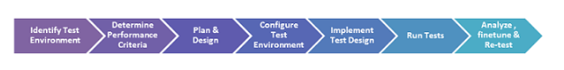

The phases of performance testing process as following:

1. Identify testing environment
2. Identify performance acceptance criteria
3. Plan and design performance tests
4. Configuring test environment
5. Implement test design
6. Run the tests
7. Analyze, tune and retest

## Performance Testing Metrics

The basic parameters monitored during performance testing include:

* Processor Usage
* Memory Usage
* Disk Time
* Bandwidth
* Private bytes
* Committed memory
* Memory Pages/Second
* Page faults/second
* CPU interrupts per second
* Disk queue length
* Network output queue length
* Network bytes total per second
* Response time
* Throughput
* Amount of connection pooling
* Maximum active sessions
* Hit ratios
* Hits per second
* Rollback segment
* Database locks
* Top waits
* Thread counts
* Garbage collection

## Performance Test Tools

Below are some examples of widely used testing tools:

* Load Ninja: [https://loadninja.com/?utm_medium=content text&utm_source=guru99&utm_campaign=perf-test-tutorial](https://loadninja.com/?utm_medium=content%20text&utm_source=guru99&utm_campaign=perf-test-tutorial)
* NeoLoad: <https://www.neotys.com/insights/performance-testing>
* JMeter: <https://www.guru99.com/jmeter-tutorials.html>

## Bibliography

*13 BEST Performance(Load) Testing Tools in 2019*. (n.d.). Retrieved from Guru99: https://www.guru99.com/performance-testing-tools.html

*Code Optimization*. (n.d.). Retrieved from ScienceDirect: https://www.sciencedirect.com/topics/computer-science/code-optimization

*Code Optimzation*. (n.d.). Retrieved from PVS-Studio: https://www.viva64.com/en/t/0084/

*Performance Testing Tutorial: What is, Types, Metrics & Example*. (n.d.). Retrieved from Guru99: https://www.guru99.com/performance-testing.html

*Pros And Cons Of Code Refactoring*. (n.d.). Retrieved from C# Corner: https://www.c-sharpcorner.com/article/pros-and-cons-of-code-refactoring/

## Glossary of Term

**Hypertext Markup Language (HTML)** - Is a standard markup language for documents designed to be displayed in a web browser

**Cascading Style Sheets (CSS)** -Is a stylesheet language used to describe the presentation of a document written in HTML or XML

**Hypertext Preprocessor (PHP)** -Is a server scripting language, and a powerful tool for making dynamic and interactive webpage

**JavaScript** - Is an object-oriented computer programming language commonly used to create interactive effects with web browsers

**Structured Query Language (SQL)** - Is used to communicate with a database and the standard language for relational database management system

# Project Management Plan Sprint Two

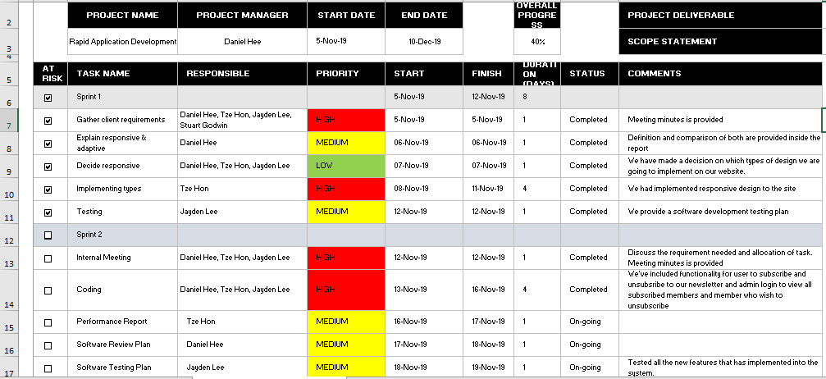

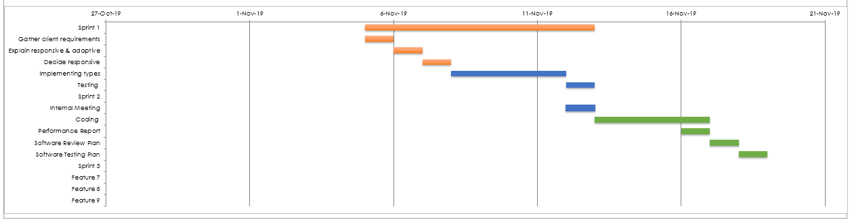

# Software Development Testing Plan for Sprint Two

## Overview

This Software Development Testing Plan (SDTP) is used to test out the features and functionality of the Responsive Design website according to the CITE Quality Assurance as below:

## Functional and Regression Testing

**Functional testing** is performed to ensure all functionalities of an application is working as expected.

**Regression testing** is performed once a build is released to check the existing functionality. (360 Logica, n.d.)

## GUI and Usability Testing

**Usability Testing** is focused on the end user and checks the impressions of the application usage.

**GUI Testing** is performed on various platforms in order to check the look and feel of the application.

(Professional QA, n.d.)

Accessibility Testing

Performed to ensure that the application being tested is usable by people with disabilities like hearing, color blindness, old age and other disadvantaged groups.

(Guru 99, n.d.)

## Compatibility Testing

Check whether the software is capable of running on different hardware, operating systems, applications, network environments or Mobile devices.

(Guru 99, n.d.)

## Performance Testing

**Performance testing** is the process of determining the speed, responsiveness and stability of a computer, network, software program or device under a workload.

(Guru 99, n.d.)

## Installation / Configuration Testing

Test the performance of a software product on a machine with different hardware or software configurations namely, operating system, browser, supported drivers.

(Guru 99, n.d.)

## System Integration Testing (SIT)

Carried out in an integrated hardware and software environment to verify the behavior of the complete system. It is testing conducted on a complete, integrated system to evaluate the system's compliance with its specified requirement.

(Wikipedia, n.d.)

## Security Testing

Ensures software systems and applications are free from any vulnerabilities, threats, risks that may cause a big loss.

(Guru 99, n.d.)

Internationalization / Localization Testing

**Internationalization** is making the application such that it supports multiple languages/locales.

**Localization** is making an application support a particular locale and language.

(Software Testing Help, n.d.)

## User Acceptance Testing (UAT)

Last phase of software testing, users test the software to make sure it can handle required tasks in real-world scenarios, according to specifications.

(Techopedia, n.d.)

## Testing Table

|  |  |  |  |  |
| --- | --- | --- | --- | --- |
| Case No | Test types | Description | Status | Evidence |
| 1 | Functional and Regression Testing | All the functions are works perfectly | Tested | Figure 1.1.1 – Figure 2.4.3 |
| 2 | GUI and Usability Testing | The website has navigation bar, text boxes and buttons to go thru | Tested | Figure 1.2.1  Figure 2 |
| 3 | Accessibility Testing | Doesn’t have any functions for disadvantages group such as deaf/blind, disabilities people. | N/A | N/A |
| 4 | Compatibility Testing | Is compatible for different platforms such as laptop, mobiles, and computers, tablets. | Tested | Figure 1.3  Figure 2.1 |
| 5 | Performance Testing | No workload is applicable in this testing | N/A | N/A |
| 6 | Installation / Configuration Testing | Work well on different operating system, browsers | Tested | Figure 1.1  Figure 2.1 |
| 7 | System Integration Testing (SIT) | Data exchanges (data import/export) happens between the system components (MySQL & HTML/PHP) and then the behavior of each data field within the individual layer is examined. | Tested | Figure 1.4 Figure 2.3.2/3 |
| 8 | Security Testing | Security features likes authorization credentials has implemented in admin login page | Tested | Figure 2.2.1 |
| 9 | Internationalization / Localization Testing | Its only available in English languages | N/A | N/A |
| 10 | User Acceptance Testing (UAT) | End users testing with the basic functions of searching movies, show all movies, and top 10 movies, admin login, memberships subscribe/unsubscribe | Tested | Figure 1  Figure 2 |

## Screenshot



Figure 1.1.1 Google Chrome browser



Figure 1.1.2 Microsoft Edge browser



Figure 1.1.3 Mozilla Firefox browser



Figure 1.2.1 – GUI – Navigation bar, text boxes, buttons, and hyperlinks

  
Figure 1.3.1 – iOS Mobile landscape mode

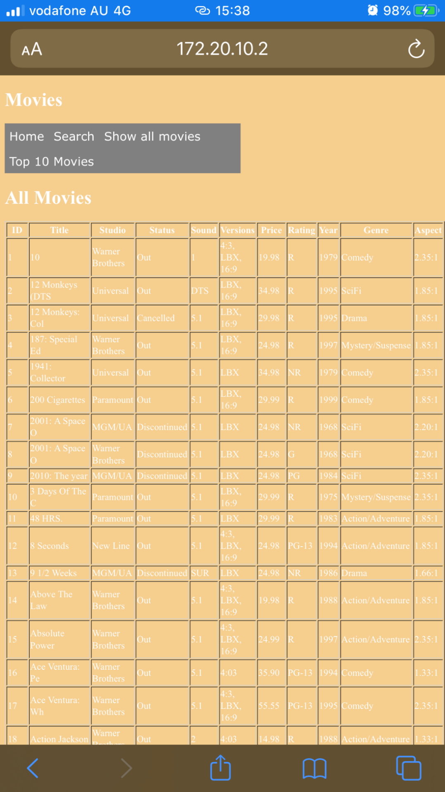  
Figure 1.3.2 – iOS Mobile portrait mode

  
Figure 1.3.3 – iOS tablet landscape mode

  
Figure 1.3.4 – iOS tablet portrait mode



Figure 1.4.1 – Search function works well with database



Figure 1.4.2 – All movies pages

Figure 2.1.1 – Scalability fixed on iOS table landscape mode

Figure 2.1.2 – Scalability fixed on iOS table portrait mode

Figure 2.1.3 – Scalability fixed on iOS mobile landscape mode

Figure 2.1.4 – Scalability fixed on iOS mobile portrait mode

Figure 2.1.5 – Scalability fixed on browser IE landscape mode  
Figure 2.1.6 – Scalability fixed on browser IE portrait mode  
Figure 2.1.7 – Scalability fixed on browser firefox landscape mode  
Figure 2.1.8 – Scalability fixed on browser firefox portrait mode  
Figure 2.1.9 – Scalability fixed on browser google chrome landscape mode  
Figure 2.1.10 – Scalability fixed on browser google chrome portrait mode

Figure 2.2.1 – Admin login features with username and password – admin/admin  
Figure 2.2.2 – Show subscribed member and member removal once admin logged in  
Figure 2.2.3 – Displayed all members  
Figure 2.3.1 – Memberships subscription page

Figure 2.3.2 – Member joins subcription added into database succesfully   
Figure 2.3.3 – Another member joins subcription added into database succesfullyA screenshot of a cell phone

Description automatically generated  
Figure 2.4.1 – Memberships unsubcribe page  
Figure 2.4.2 – Enter email wanted to unsubcribe and it will prompt a compose mail to the administrator email address in order to unsubscribe on behalf.

Figure 2.4.3 – Administrator email address received unsubscribe email from member.

## Bibliography

*360 Logica*. (n.d.). Retrieved from https://www.360logica.com/blog/regression-testing-vs-functional-testing/

*CITE Managed Services*. (n.d.). Retrieved from http://www.citems.com.au/?page_id=84

*Guru 99*. (n.d.). Retrieved from https://www.guru99.com/accessibility-testing.html

*Guru 99*. (n.d.). Retrieved from https://www.guru99.com/compatibility-testing.html

*Guru 99*. (n.d.). Retrieved from Performance Testing: https://www.guru99.com/performance-testing.html

*Guru 99*. (n.d.). Retrieved from Configuration Testing: https://www.guru99.com/configuration-testing.html

*Guru 99*. (n.d.). Retrieved from Security Testing: https://www.guru99.com/what-is-security-testing.html

*Professional QA*. (n.d.). Retrieved from http://www.professionalqa.com/gui-testing-vs-usability-testing

*Software Testing Help*. (n.d.). Retrieved from Localization and Internationalization: https://www.softwaretestinghelp.com/localization-and-internationalization-testing/

*Techopedia*. (n.d.). Retrieved from UAT: https://www.techopedia.com/definition/3887/user-acceptance-testing-uat

*Wikipedia*. (n.d.). Retrieved from System Integration Testing: https://en.wikipedia.org/wiki/System_integration_testing

## Glossary of Term

**System Integration Testing (SIT)** – This is a software solution designed to deliver instructional content.

**User Acceptance Testing (UAT)** – This is last phase of the software testing process. During this phase, actual software users test the software to make sure it can handle required tasks in real-world scenarios, according to specifications.

**Graphic User Interface (GUI)** – This is a form of user interface that allows users to interact with electronic devices through graphical icons and audio indicator.

**Structured Query Language (MySQL)** - This is an open-source relational database management system. Its name is a combination of “My”, the name of co-founder Michael Widenius’s daughter, and “SQL”, the abbreviation for Structured Query Language.

**Hypertext Mark-up Language (HTML)** – This is the standard mark-up language for documents designed to be displayed in a web browser.

**Hypertext Pre-processor (PHP)** – This is a general-purpose programming language originally designed for web development.